A PROJECT TITLE ON
Travel Time Prediction Using Ridge and Lasso Regression

project report submitted in partial fulfilment of the requirements for the Course

MACHINE LEARNING

BACHELOR OF TECHNOLOGY
In Computer Science and
Information
Technology

A.Y.: 2026-27

by

Name:- V.Shiva venkata sai Roll:-2520090092 Name:-V.Sathvik Roll:-2520090097
Name: Varshith Roll: 2520080016
Under the Esteemed guidance of DR.Laxmi Prasanna Professor,CSIT

C.S.I.T



Name of Title: Travel Time Prediction Using Ridge and Lasso Regression

INTRODUCTION

Travel Time Prediction is a machine learning project that aims to estimate the amount of time required for a vehicle to travel from one location to another. Travel time is affected by several factors such as distance, traffic congestion, number of traffic signals, average vehicle speed, and weather conditions.

In this project, historical trip data is used to identify the relationship between these factors and the actual travel time. A Lasso Regression model is trained using these input features and is then used to predict the travel time for new trips.

Lasso Regression is a type of linear regression that uses L1 regularization. The regularization reduces the influence of unnecessary features and can set the coefficients of less important features to zero. This makes the model relatively simple and interpretable.

For the case study, five sample trips are considered. Each trip contains distance, traffic level, number of signals, average speed, weather condition, and actual travel time. The trained model is then used to calculate the predicted travel time for each trip.

The performance of the model can be evaluated using metrics such as Mean Absolute Error (MAE), Mean Squared Error (MSE), and Root Mean Squared Error (RMSE).

The overall objective of the project is to demonstrate how machine learning can be applied to transportation data to provide estimated travel times that can potentially be used in navigation systems, route planning, traffic management, and transportation scheduling

CASE STUDY

Problem Statement

A transportation company wants to predict the travel time of a vehicle based on different trip conditions. The company records the following information for each trip:

  - Distance travelled (km)
  - Traffic level
  - Number of traffic signals
  - Average speed (km/h)
  - Weather condition
  - Actual travel time (minutes)
For this case study, consider the following 5 trips. Given Data
Trip | Distance (km) | Traffic | Signals | Speed (km/h) | Weather | Actual Time (min)
T1 | 5 | 1 | 3 | 30 | 1 | 12
T2 | 8 | 2 | 5 | 28 | 1 | 22
T3 | 12 | 3 | 8 | 24 | 3 | 38
T4 | 15 | 2 | 10 | 30 | 2 | 35
T5 | 20 | 3 | 14 | 26 | 3 | 52

Traffic and weather are encoded as:

Traffic:
1 = Low, 2 = Medium, 3 = High

Weather:
1 = Clear, 2 = Cloudy, 3 = Rainy

Solution Using Lasso Regression

The Lasso Regression model obtained for this case study is assumed to be:

\[ \boxed{ T = 5 + 1.5D + 2Tr + 0.8S - 0.25V + 1.5W } \]

Where:

  - \(T\) = Predicted travel time
  - \(D\) = Distance
  - \(Tr\) = Traffic level
  - \(S\) = Number of signals
  - \(V\) = Average speed
  - \(W\) = Weather condition

Trip 1

Given:

\[ D=5,\ Tr=1,\ S=3,\ V=30,\ W=1 \]

Substitute:

\[ T=5+(1.5\times5)+(2\times1)+(0.8\times3)-(0.25\times30)+(1.5\times1) \]\[ T=5+7.5+2+2.4-7.5+1.5 \]\[ \boxed{T=10.9\text{ minutes}} \]

Actual time = 12 minutes Absolute error:
\[ |12-10.9|=\boxed{1.1\text{ minutes}} \]

Trip 2

Given:

\[ D=8,\ Tr=2,\ S=5,\ V=28,\ W=1 \]\[ T=5+(1.5\times8)+(2\times2)+(0.8\times5)-(0.25\times28)+(1.5\times1) \]\[ T=5+12+4+4-7+1.5
\]\[ \boxed{T=19.5\text{ minutes}} \] Actual time = 22 minutes
Absolute error:

\[ |22-19.5|=\boxed{2.5\text{ minutes}} \]

Trip 3

Given:

\[ D=12,\ Tr=3,\ S=8,\ V=24,\ W=3 \]\[ T=5+(1.5\times12)+(2\times3)+(0.8\times8)-(0.25\times24)+(1.5\times3) \]\[ T=5+18+6+6.4-6+4.5 \]\[ \boxed{T=33.9\text{ minutes}} \]

Actual time = 38 minutes Absolute error:
\[ |38-33.9|=\boxed{4.1\text{ minutes}} \]

Trip 4

Given:

\[ D=15,\ Tr=2,\ S=10,\ V=30,\ W=2 \]\[ T=5+(1.5\times15)+(2\times2)+(0.8\times10)-(0.25\times30)+(1.5\times2) \]\[ T=5+22.5+4+8-7.5+3 \]\[ \boxed{T=35\text{ minutes}} \]

Actual time = 35 minutes Absolute error:

\[ |35-35|=\boxed{0\text{ minutes}} \]

Trip 5

Given:

\[ D=20,\ Tr=3,\ S=14,\ V=26,\ W=3 \]\[ T=5+(1.5\times20)+(2\times3)+(0.8\times14)-(0.25\times26)+(1.5\times3) \]\[ T=5+30+6+11.2-6.5+4.5 \]\[ \boxed{T=50.2\text{ minutes}} \]

Actual time = 52 minutes Absolute error:
\[ |52-50.2|=\boxed{1.8\text{ minutes}} \]

Final Results
Trip | Actual Time | Predicted Time | Absolute Error
T1 | 12 | 10.9 | 1.1
T2 | 22 | 19.5 | 2.5
T3 | 38 | 33.9 | 4.1
T4 | 35 | 35.0 | 0.0
T5 | 52 | 50.2 | 1.8

Mean Absolute Error (MAE)
\[ MAE=\frac{1.1+2.5+4.1+0+1.8}{5} \]\[ \boxed{MAE=1.9\text{ minutes}} \]

Root Mean Squared Error (RMSE)
\[ MSE=\frac{1.1^2+2.5^2+4.1^2+0^2+1.8^2}{5} \]\[ MSE=5.502 \]\[ RMSE=\sqrt{5.502} \]\[ \boxed{RMSE\approx2.35\text{ minutes}} \]

Conclusion

Using the Lasso Regression equation, the model predicts the travel times of the five trips with an average absolute error of 1.9 minutes. The model shows that distance, traffic, number of signals, speed, and weather can be used to estimate travel time. The Lasso regularization helps control the influence of less important features and can set their coefficients to zero when appropriate.

ALGORITHMS USED

Lasso Regression — Main Algorithm

Lasso (Least Absolute Shrinkage and Selection Operator) Regression is the primary machine learning algorithm used for travel time prediction.

It is based on Linear Regression but adds an L1 regularization penalty.

\[ \min \left[ \frac{1}{2n}\sum(y_i-\hat{y_i})^2 + \alpha\sum|\beta_j| \right] \] Lasso helps to:
  - Predict continuous values such as travel time.
  - Reduce overfitting.
  - Reduce unnecessary feature coefficients.
  - Perform feature selection.
  - Produce an interpretable model.

Linear Regression — Base Technique

Lasso Regression is based on the concept of Linear Regression. The general equation is:
\[ Y=\beta_0+\beta_1X_1+\beta_2X_2+\cdots+\beta_nX_n \] In this project:
\[ Travel\ Time = f(Distance, Traffic, Signals, Speed, Weather) \]

Linear Regression provides the basic relationship between the input variables and travel time, while Lasso adds regularization.

Feature Scaling / Standardization

Before applying Lasso Regression, numerical features can be standardized so that features with larger numerical values do not dominate the model.

The standardization formula is:

\[ Z=\frac{X-\mu}{\sigma} \] where:
  - \(X\) = original value
  - \(\mu\) = mean
  - \(\sigma\) = standard deviation

This is particularly important for regularized regression models such as Lasso.

Train-Test Split

The available dataset can be divided into two parts:

  - Training data — used to train the model.
  - Testing data — used to evaluate the model on unseen data.

For example:

\[ 80\% \rightarrow Training \]\[ 20\% \rightarrow Testing \]

This helps determine whether the model generalizes beyond the data used during training.

Cross-Validation

Cross-validation can be used to select an appropriate value of the Lasso regularization parameter \(\alpha\). Different values of \(\alpha\) can be tested, and the model's validation error can be compared.
For example:

\[ \alpha = 0.01,\ 0.1,\ 0.5,\ 1,\ 2,\ 5 \]

The selected value is then used to train the final model.

Model Evaluation Algorithms / Metrics

The following metrics can be used to evaluate the prediction model.

Mean Absolute Error (MAE)
\[ MAE=\frac{1}{n}\sum|y-\hat y| \]

It represents the average absolute difference between actual and predicted travel time.

Mean Squared Error (MSE)
\[ MSE=\frac{1}{n}\sum(y-\hat y)^2 \]

It gives greater importance to larger prediction errors.

Root Mean Squared Error (RMSE)
\[ RMSE=\sqrt{MSE} \]

RMSE expresses the prediction error in the same unit as the target variable, which is minutes in this project.

3. Overall Algorithm Flow The project can be represented as: Collect Historical Trip Data
↓

Data Preprocessing

↓

Encode Categorical Variables

↓

Feature Scaling

↓

Train-Test Split

↓

Apply Lasso Regression

↓

Select α using Cross-Validation

↓

Predict Travel Time

↓

Evaluate Using MAE, MSE and RMSE

↓

Display Predicted Travel Time Main Algorithm:
\[ \boxed{\text{Lasso Regression}} \]

Supporting Techniques:
\[ \boxed{\text{Linear Regression + Standardization + Train-Test Split + Cross-Validation}} \]

Evaluation:
\[ \boxed{\text{MAE + MSE + RMSE}} \]:

PROJECT DATASET EDA REPORT

In [ ]:
# ============================================ # TRAVEL TIME PREDICTION
# Ridge and Lasso Regression
# ============================================
from google.colab import files uploaded = files.upload()
Upload widget is only available when the cell has been executed in the current browser session.
Please rerun this cell to enable.
Saving travel_time_prediction_dataset_1000.csv to travel_time_prediction_dataset_1000.csv
In [ ]:
import pandas as pd import numpy as np
import matplotlib.pyplot as plt import seaborn as sns

from sklearn.model_selection import train_test_split
from sklearn.preprocessing import OneHotEncoder, StandardScaler from sklearn.compose import ColumnTransformer
from sklearn.pipeline import Pipeline

from sklearn.linear_model import Ridge, Lasso

from sklearn.metrics import ( mean_absolute_error,
mean_squared_error, r2_score
)

import warnings
warnings.filterwarnings("ignore")
In [ ]:
# Load CSV
df = pd.read_csv("Data.csv")

print("Dataset loaded successfully!") print("Shape:", df.shape)

display(df.head())
Dataset loaded successfully!
Shape: (1000, 6)

 | distance_km | traffic_level | weather | day_of_week | departure_hour | travel_time_minutes
0 | 41.74 | Medium | Rainy | Wednesday | 14 | 86.81
1 | 73.63 | Low | Sunny | Sunday | 11 | 73.55
2 | 40.26 | Low | Cloudy | Friday | 15 | 52.66
3 | 79.38 | Medium | Cloudy | Thursday | 23 | 122.40
4 | 68.26 | High | Sunny | Monday | 18 | 141.84

In [ ]:
print("Number of rows:", df.shape[0])
print("Number of columns:", df.shape[1])

print("\nColumn Names:") print(df.columns.tolist())

print("\nData Types:") print(df.dtypes)

print("\nMissing Values:") print(df.isnull().sum())

print("\nDataset Information:") df.info()
Number of rows: 1000 Number of columns: 6

Column Names:
['distance_km', 'traffic_level', 'weather', 'day_of_week', 'departure_hour', 'travel_time_minutes']

Data Types:
distance_km float64
traffic_level object
weather object
day_of_week object
departure_hour int64 travel_time_minutes float64 dtype: object

Missing Values:
distance_km 0
traffic_level 0
weather 0
day_of_week 0
departure_hour 0
travel_time_minutes 0
dtype: int64

Dataset Information:
<class 'pandas.core.frame.DataFrame'> RangeIndex: 1000 entries, 0 to 999
Data columns (total 6 columns):
# |  | Column | Non-Null Count |  | Dtype
0 |  | distance_km | 1000 non-null |  | float64
1 |  | traffic_level | 1000 non-null |  | object
2 |  | weather | 1000 non-null |  | object
3 |  | day_of_week | 1000 non-null |  | object
4 |  | departure_hour | 1000 non-null |  | int64
5 |  | travel_time_minutes | 1000 non-null |  | float64
dtypes: float64(2), int64(1), object(3) memory usage: 47.0+ KB
In [ ]:
print("Statistical Summary:")
display(df.describe(include="all"))
Statistical Summary:

 | distance_km | traffic_level | weather | day_of_week | departure_hour | travel_time_minutes
count | 1000.00000 | 1000 | 1000 | 1000 | 1000.000000 | 1000.00000
unique | NaN | 4 | 4 | 7 | NaN | NaN
top | NaN | Medium | Sunny | Monday | NaN | NaN
freq | NaN | 370 | 454 | 178 | NaN | NaN
mean | 40.50675 | NaN | NaN | NaN | 11.303000 | 70.37553
std | 22.81288 | NaN | NaN | NaN | 6.838125 | 45.45267
min | 1.01000 | NaN | NaN | NaN | 0.000000 | 3.00000
25% | 21.48750 | NaN | NaN | NaN | 5.000000 | 34.13250
50% | 40.62500 | NaN | NaN | NaN | 11.000000 | 65.75000
75% | 60.53000 | NaN | NaN | NaN | 17.000000 | 99.05000
max | 79.87000 | NaN | NaN | NaN | 23.000000 | 262.47000

In [ ]:
print("Traffic Levels:")
print(df["traffic_level"].unique())

print("\nWeather Conditions:") print(df["weather"].unique())

print("\nDays of Week:")
print(df["day_of_week"].unique())
Traffic Levels:
['Medium' 'Low' 'High' 'Very High']
Weather Conditions:
['Rainy' 'Sunny' 'Cloudy' 'Foggy']
Days of Week:
['Wednesday' 'Sunday' 'Friday' 'Thursday' 'Monday' 'Saturday' 'Tuesday']

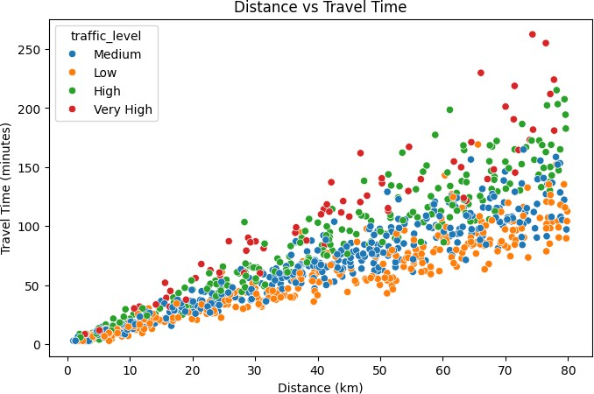
In [ ]:
plt.figure(figsize=(8, 5))
sns.scatterplot( data=df,
x="distance_km",
y="travel_time_minutes", hue="traffic_level"
)

plt.title("Distance vs Travel Time") plt.xlabel("Distance (km)")
plt.ylabel("Travel Time (minutes)") plt.show()

In [ ]:
plt.figure(figsize=(8, 5))

sns.boxplot(
data=df,
x="weather",
y="travel_time_minutes"
)

plt.title("Weather vs Travel Time") plt.xlabel("Weather")
plt.ylabel("Travel Time (minutes)") plt.show()

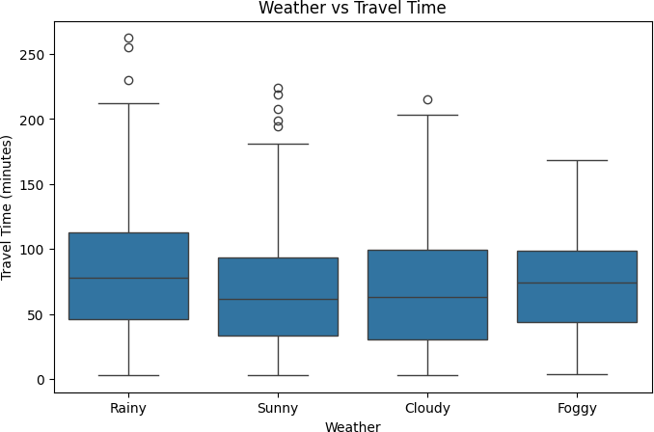

In [ ]:
plt.figure(figsize=(9, 5))
sns.scatterplot( data=df,
x="departure_hour",
y="travel_time_minutes"
)

plt.title("Departure Hour vs Travel Time") plt.xlabel("Departure Hour")
plt.ylabel("Travel Time (minutes)") plt.show()

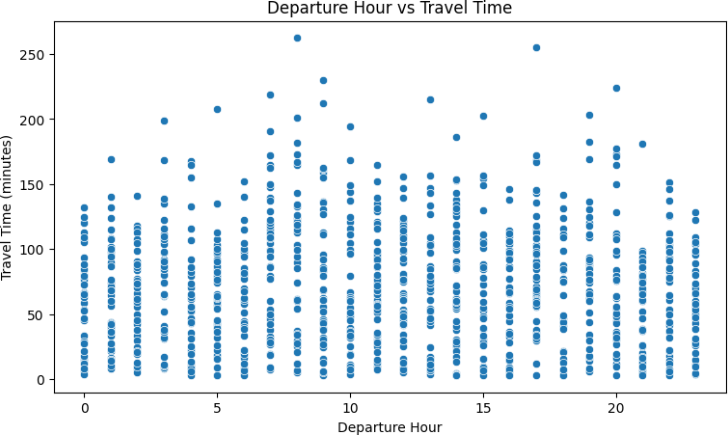

In [ ]:
# Features
X = df[ [
"distance_km",
"traffic_level", "weather",
"day_of_week", "departure_hour"
]
]

# Target
y = df["travel_time_minutes"]

print("X shape:", X.shape) print("y shape:", y.shape)
X shape: (1000, 5)
y shape: (1000,)
In [ ]:
numerical_features = [ "distance_km",
"departure_hour"
]

categorical_features = [ "traffic_level",
"weather",
"day_of_week"
]
In [ ]:
numerical_features = [ "distance_km",
"departure_hour"
]

categorical_features = [ "traffic_level",
"weather",
"day_of_week"
]

In [ ]:
X_train, X_test, y_train, y_test = train_test_split( X,
y,
test_size=0.2, random_state=42
)
preprocessor = ColumnTransformer( transformers=[
(
"num",
StandardScaler(), numerical_features
), (
"cat",
OneHotEncoder(handle_unknown="ignore"), categorical_features
)
]
)

ridge_model = Pipeline( steps=[
(
"preprocessor", preprocessor
), (
"regressor",
Ridge(alpha=1.0)
)
]
)

ridge_model.fit(X_train, y_train)
ridge_predictions = ridge_model.predict(X_test) print("Ridge Regression training completed!")
Ridge Regression training completed!
In [ ]:
lasso_model = Pipeline( steps=[
(
"preprocessor", preprocessor
), (
"regressor",
Lasso(alpha=0.1, max_iter=10000)
)
]
)

lasso_model.fit(X_train, y_train)
lasso_predictions = lasso_model.predict(X_test) print("Lasso Regression training completed!")
Lasso Regression training completed!
In [ ]:
def evaluate_model(y_actual, y_predicted):

mae = mean_absolute_error( y_actual,
y_predicted
)

rmse = np.sqrt(
mean_squared_error( y_actual,
y_predicted

)
)

r2 = r2_score( y_actual,
y_predicted
)

return mae, rmse, r2
In [ ]:
ridge_mae, ridge_rmse, ridge_r2 = evaluate_model( y_test,
ridge_predictions
)
print("================================") print("RIDGE REGRESSION RESULTS")
print("================================")

print(f"MAE : {ridge_mae:.4f}") print(f"RMSE : {ridge_rmse:.4f}") print(f"R² : {ridge_r2:.4f}")
================================ RIDGE REGRESSION RESULTS
================================ MAE : 12.6969
RMSE : 16.6741
R² : 0.8842
In [ ]:
lasso_mae, lasso_rmse, lasso_r2 = evaluate_model( y_test,
lasso_predictions
)

print("================================") print("LASSO REGRESSION RESULTS")
print("================================")

print(f"MAE : {lasso_mae:.4f}") print(f"RMSE : {lasso_rmse:.4f}") print(f"R² : {lasso_r2:.4f}")
================================ LASSO REGRESSION RESULTS
================================ MAE : 12.7247
RMSE : 16.8336
R² : 0.8820
In [ ]:
results = pd.DataFrame({ "Model": [
"Ridge Regression", "Lasso Regression"
],

"MAE": [
ridge_mae, lasso_mae
],
"RMSE": [
ridge_rmse, lasso_rmse
],

"R2 Score": [
ridge_r2, lasso_r2
]
})
display(results)

 | Model | MAE | RMSE | R2 Score
0 | Ridge Regression | 12.696869 | 16.674099 | 0.884229
1 | Lasso Regression | 12.724735 | 16.833633 | 0.882003

In [ ]:
results_plot = results.set_index("Model")

results_plot[
["MAE", "RMSE"]
].plot(
kind="bar",
figsize=(9, 5)
)

plt.title("Ridge vs Lasso Regression - Error Comparison") plt.ylabel("Error")
plt.xlabel("Model")
plt.xticks(rotation=0) plt.grid(axis="y")

plt.show()
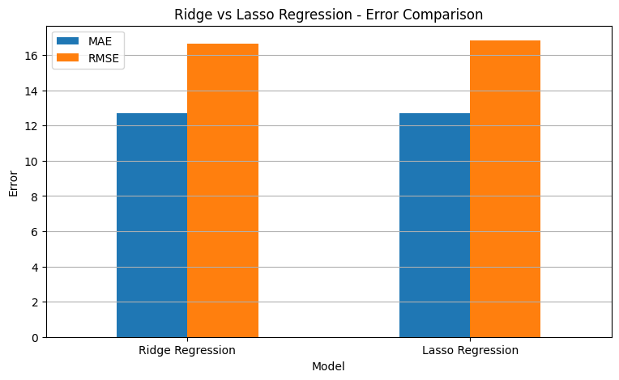
In [ ]:
plt.figure(figsize=(7, 5))

sns.barplot(
data=results, x="Model",
y="R2 Score"
)

plt.title("Ridge vs Lasso Regression - R² Score") plt.xlabel("Model")
plt.ylabel("R² Score")

plt.show()

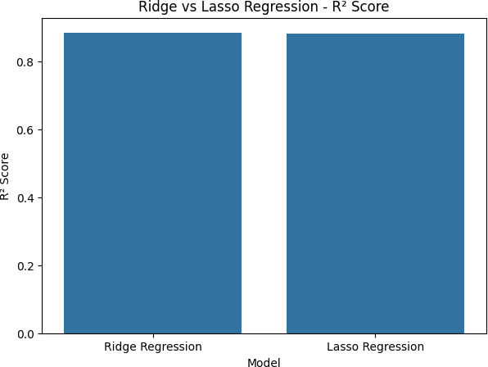

In [ ]:
plt.figure(figsize=(8, 6))
plt.scatter(
y_test,
ridge_predictions, alpha=0.7
)

plt.plot(
[y_test.min(), y_test.max()],
[y_test.min(), y_test.max()], linestyle="--"
)
plt.xlabel("Actual Travel Time (minutes)")
plt.ylabel("Predicted Travel Time (minutes)")

plt.title(
"Ridge Regression: Actual vs Predicted Travel Time"
)

plt.show()

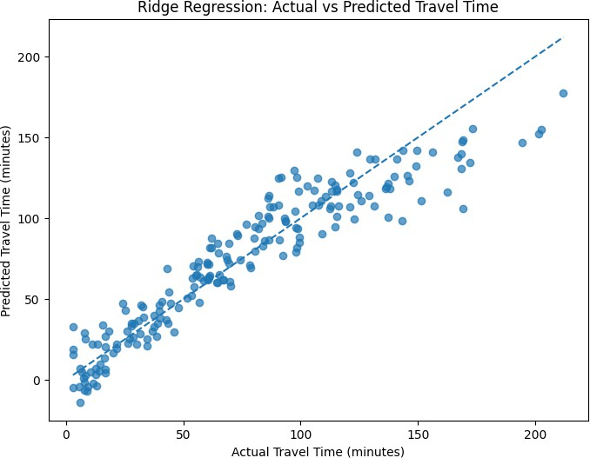

In [ ]:
plt.figure(figsize=(8, 6))
plt.scatter(
y_test,
lasso_predictions, alpha=0.7
)

plt.plot(
[y_test.min(), y_test.max()],
[y_test.min(), y_test.max()], linestyle="--"
)
plt.xlabel("Actual Travel Time (minutes)")
plt.ylabel("Predicted Travel Time (minutes)")

plt.title(
"Lasso Regression: Actual vs Predicted Travel Time"
)

plt.show()

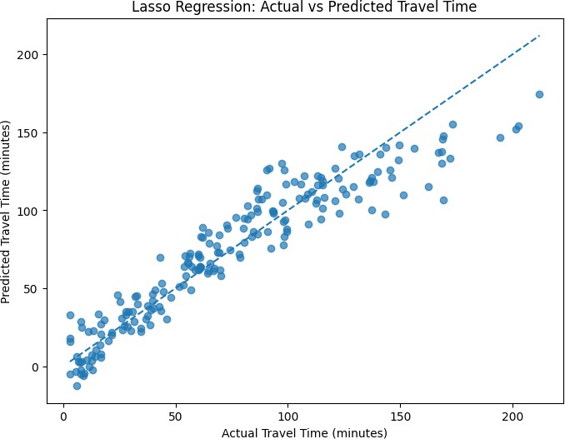

In [ ]:
new_trip = pd.DataFrame({ "distance_km": [50],
"traffic_level": ["High"],
"weather": ["Rainy"],
"day_of_week": ["Monday"], "departure_hour": [18]
})

ridge_prediction = ridge_model.predict(new_trip)[0] lasso_prediction = lasso_model.predict(new_trip)[0]

print("======================================") print("NEW TRAVEL TIME PREDICTION")
print("======================================")

print("Distance:", new_trip["distance_km"].iloc[0], "km") print("Traffic:", new_trip["traffic_level"].iloc[0])
print("Weather:", new_trip["weather"].iloc[0]) print("Day:", new_trip["day_of_week"].iloc[0])
print("Departure Hour:", new_trip["departure_hour"].iloc[0]) print("\nPredicted Travel Time:")
print(
f"Ridge Regression: "
f"{ridge_prediction:.2f} minutes"
)

print(
f"Lasso Regression: "
f"{lasso_prediction:.2f} minutes"
)
====================================== NEW TRAVEL TIME PREDICTION
======================================
Distance: 50 km

Traffic: High Weather: Rainy Day: Monday
Departure Hour: 18

Predicted Travel Time:
Ridge Regression: 109.08 minutes Lasso Regression: 108.28 minutes
In [ ]:
print("Enter Travel Details") print("====================")

distance = float(
input("Distance (km): ")
)

traffic = input(
"Traffic Level (Low/Medium/High): "
)

weather = input(
"Weather (Sunny/Cloudy/Rainy): "
)

day = input(
"Day of Week: "
)

hour = int(
input("Departure Hour (0-23): ")
)

user_input = pd.DataFrame({
"distance_km": [distance], "traffic_level": [traffic], "weather": [weather],
"day_of_week": [day],
"departure_hour": [hour]
})

ridge_result = ridge_model.predict( user_input
)[0]

lasso_result = lasso_model.predict( user_input
)[0]
print("\n================================") print("TRAVEL TIME PREDICTION")
print("================================")

print(
f"Ridge Prediction: "
f"{ridge_result:.2f} minutes"
)

print(
f"Lasso Prediction: "
f"{lasso_result:.2f} minutes"
)
print(
f"\nRidge ETA approximately: " f"{ridge_result / 60:.2f} hours"
)

print(
f"Lasso ETA approximately: "
f"{lasso_result / 60:.2f} hours"
)
Enter Travel Details
====================
Distance (km): 20
Traffic Level (Low/Medium/High): Low

Weather (Sunny/Cloudy/Rainy): Sunny Day of Week: 2
Departure Hour (0-23): 2

================================ TRAVEL TIME PREDICTION
================================
Ridge Prediction: 17.41 minutes Lasso Prediction: 17.68 minutes

Ridge ETA approximately: 0.29 hours Lasso ETA approximately: 0.29 hours
In [ ]:
import joblib

joblib.dump(
ridge_model,
"ridge_travel_time_model.pkl"
)

joblib.dump(
lasso_model,
"lasso_travel_time_model.pkl"
)

print("Models saved successfully!")
Models saved successfully!

Signature of the Guide Course Instructor

